12/4/2017
Exhibition Proposal
African American Literary and Art works
Meaeel Alraithi
Am2010am11@hotmail.com
352-575-5356

Abstract
African American Literary and Art works
Seton Hall University through the Walsh Gallery “Art Appreciation” has the potential to expose its students to wide learning opportunities through art that will have an exhibition which portrays how slavery achieved numerous positive changes in the African American culture. The African American creative arts of literature, artworks have changed over time. These changes are a manifestation of political, educational and economic evolution. These learning opportunities can be achieved describing various literature and artworks of the African American community. The exhibition will have the role of making the audience aware of the 19th century art about slave narratives. As a teaching art exhibition, in particular help students to understand historical aspects and African American cultures better because of the intellectual enrichment they achieve through art.
Certain ways of movement and expressing art are cultural manifestations that seem to remain even though they have become intermingled with other artistic attributes through assimilation. Periods through history have changed, and these changes have brought with them changes in economics, region, the environment, people’s status, education, and ultimately their views. As life became radically different, so did the creative expression of African Americans because art mirrors life and is a view into the souls of a people. The exhibition helps to bring into focus this group and reduce the negativity that sometimes is directed towards a good number of individuals within this part of society. All the objects will be branded in such a way that they will have information that are related to the African American literary works. The artwork will involve exhibitions which depict how slavery brought about many positive changes in the African American society. There are several objects that will be used in the exhibition which have the inclusion of books and paintings. Paintings and books such as escape from slavery, the other blacklist and passed storm will be of great benefit in bringing out the African American literary art. All objects will bring up the basis of the art and how the past was influence by several activities that were done by people. Exhibition Narrative
The exhibition will be aimed at the showing the main idea of describing various literature and visual arts of the African-American community. The exhibition will be made dynamic such that there should be a clear mention of each of the aspects of the theme. The exhibition will have the role of making the audience aware of the 19th-century art about slave narratives. As a teaching art exhibition, in particular help students to understand historical aspects and African American cultures better because of the intellectual enrichment they achieve through art.
There are several objects that will be used in the exhibition which will have the inclusion of visual arts which will include videos, photos, ancient paintings, and books that will be focusing on the African American art. The visual arts will be used in the way in which the videos are shown to the audience and a clear explanation made such that they will understand what is being shown. There would be an interpreter for this purpose who will be the main person to give an interpretation. Photos would include those that are from the galleries, of course borrowing will be done for the purpose of making the theme clearly elaborated. The photos will be those that are from the ancient times during the period that the theme happened. The photos will be accompanied with the ancient paintings that clearly elaborates the theme. In the long run, there would be an individual who will be in the course of things to make sure that the paintings are clearly interpreted according to the theme. The books will be displayed in a certain place and the pages that have information of the theme should be made and allow for the audience to go through them and make the understanding on the theme of the exhibition.
The exhibition would have collaboration with some of the museums in the in new jersey such as Montclair Art Museum and the Newark Museum. Of course, it will depend on the standards that they have and will allow for the successful borrowing of some of the objects that would be used in the exhibition. Specifically, the Newark Museum will be the best collaboration museum that will help in the success of the exhibition. Their vision of partnering with the local community will be the basis of borrowing some of the materials from them. The budget will also fit in the museum’s terms and conditions and would allow for the start of an exhibition.
The specific art objects that would be borrowed from the museum are the books, pictures, the ancient paintings and the visual arts. The search for those that are with the theme of the exhibition will be required and a budget made for the purpose of having the better approaches. Loaning would be the best way to go for the museum. Furthermore, the exhibition helps to bring into focus this group and reduce the negativity that sometimes is directed towards a good number of individuals within this part of society. I will be borrowed some artefacts that relate to African American art from the Newark Museum. They will include photos, paintings, books and visual art. The objects that are loaned from the Newark Museum will be brought to Seton Hall University by a rented van. This is because they have standards that are not as rigorous as those of lending a larger museum. The works of art in the exhibition tells the Seton Hall University’s students about the unique stories they tell about the lives and culture of African Americans. It will confine its context to the mission statements of Seton Hall University where most of the exhibition will be provided in a way that makes the students make a better learning about African American arts.
Programs
For the exhibition being successful, there should be several aspects that should be considered. Basing on the theme, there should be three people that will act for the purpose of explaining to the audience the terms and the details of the African America literally works. They will be arranged in the various sections basing on the objects that are available. As said, there would be the use of ancient paintings, images , and visual arts. At list one person should be responsible in explaining to the audience what happens in each of the objects in relation to the theme.
The exhibition will be set into several sections. The selection of the hall on the Seton Hall will be based on the number of audience that will attend. Generally, the room or hall that is chosen should be arranged in a way that all the objects can be shown. A section of the ancient paintings can be made available where the audience will be passing over and a patron explains to them what the paintings will be meaning. The next section can be the pictures section. The pictures should be placed under plexi glass that will make sure that it protects them from any harm from the audience. They would make sure that every aspect of the theme is clear and made to point that the audience can take.
paintings and images should be displayed on the Walsh gallery's walls .also, these objects that talk about the theme will be important and will allow for the clear understanding of the exhibition theme. There can be allowance of the audience to take the books to the exhibition hall such that they will refer in most cases. The last arrangement part will be the visual arts side. This is where video can be shown and made clear of how the theme comes in. in this side, the audience would be sited and they will be watching and making comments on what is happening. The patron on this side would be making comments on what is happening with the shown video.
Target audience
The target audience for the exhibition are students, researchers and the general public. There will be the need to give the information of how the necessary information are placed on the objects so that there will be the necessity of them to understand. The Africa America art should be explained in detail and make sure that the audience are comfortable with the content. As a good approach, there should be the arranging of the floor plan in a way that will please all the audience and will make all of them have participation on the long run. The availability of good approaches in making the exhibitions will ensure that the exhibition will be successful and in the long run be used in other ways. For the success to be achieved, the correct staff and working personnel will be used.
Public relations
Before the exhibition opens, there should be the campaign to make sure that the target audience have the knowledge that there will be an exhibition. Our public relations team will have the use of visual abilities to make the exhibition known. The print media will as well be used in publicizing the event. The main theme will be made sure that it is made known to every other person who will be willing to join. The ability to convey the main theme will be the main aim and will ensure that there is the availability of the correct information and channels to evaluate how the exhibition will be portrayed. The social media will also be used to publicize the activity. It will be used as a basis of having enough gathering to check on the exhibition.
Design
The exhibition materials that will be used in the event will need special installation. The pictures and the paintings will have to be placed on different places in the gallery and will allow for better arrangements of the information. The installation procedures should make sure that there is a systematic approach in making sure that the audience have viewed the exhibition and allow for the conveying the information about the African America art and literary . Lighting should also be a main feature to be considered and do not influence my objects that will be presented. There should be the use of good lighting to make sure that all the materials can be seen without any difficulty at all by the audience. I will use video that is the main feature of my project, but I put it on my website so I could link it to additional information about the causes of lack of respect for art and literary in African American and how we can help to avoid these causes. Hopefully my project will educate people and make them think about how their choices can positively influence how to develop art and literature to keep it from disappearing in the world. Also, I will bring some chairs that will be used for audience to watch the objects in the Walsh gallery.

Exhibition Budget

Exhibition checklist
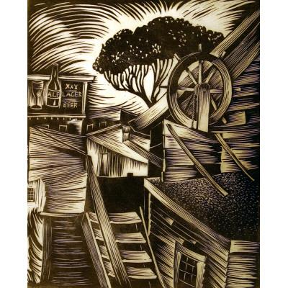
Object Name: Boat Houses
Date:1938
Artist: Wilmer Jennings
Rhode Island
Linocut on Japanese paper, Paper W: 27.70 cm, Paper H: 40.00 cm, Image W: 21.60 cm, H: 26.40 cm
Allocated by the U. S. Government, 1943. Commissioned through the New Deal art projects 43.505
Accession number:1945.45.1234
Keywords: African American, Residential
Location: The Newark museum
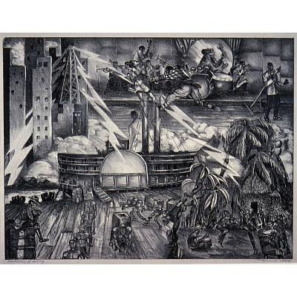
Object Name: The Evolution of Swing, ca.
Date:1935
Artist: Raymond Steth
Lithograph on cream paper, Paper W: 19 in, Paper H: 14 in, Image W: 16 3/4 in, Image H: 12 7/8 in, Mat W: 22 in, Mat H: 18 in
Accession number: 1945 45.727
Keywords: African American, Music, Dance, Slavery, Africa, Primitivism, River boat.
Location: The Newark Museum

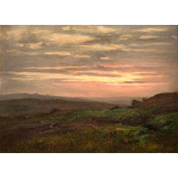
Painting

Object Name: Passed Storm, ca.
Date:1880
Artist: Bannister, Edward Mitchell
Oil on artist board
Dimensions: 6 1/4 x 8 1/4 in. (15.9 x 21 cm)
Accession number: 2003.21
Location: Montclair Art Museum

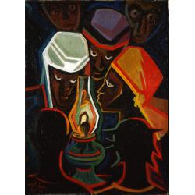
Object Name: Blackout in Haiti
Date: 1964
Artist: Jones, Lois Mailou (American, 1905-1998)
Oil on burlap

frame: 37 x 29 1/2 in. (94 x 74.9 cm)
Dimensions: 29 x 21 in. (73.7 x 53.3 cm)
Accession number: 1991.14
Location: Montclair Art Museum

SCULPTURE
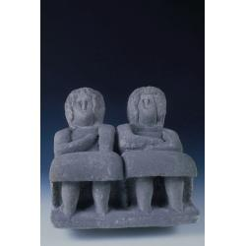
Po'ch Ladies, ca.
Date : 1941
Artist: Edmondson, William (American, 1874-1951)
Limestone
Dimensions: 11 3/4 x 13 1/2 x 15 1/2 in. (29.8 x 34.3 x 39.4 cm)
Accession number: 1973.2
Location: Montclair Art Museum

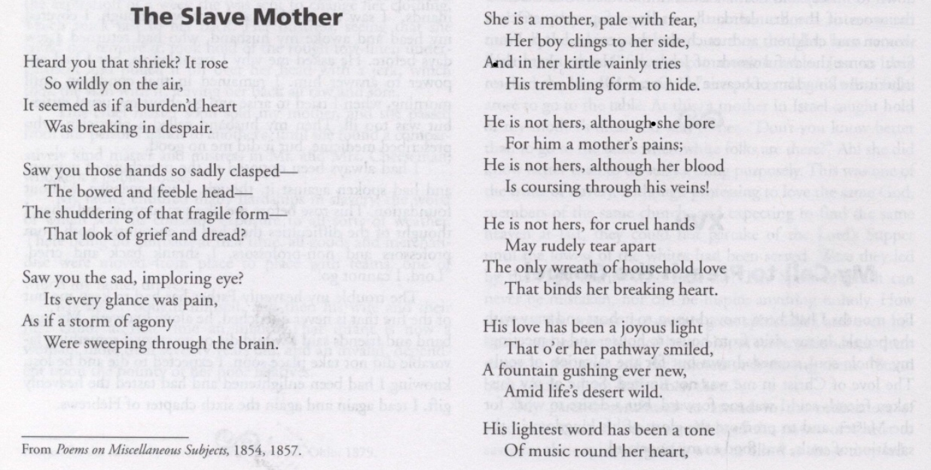

The Salve Mother (Frances Ellen Watkins Harper 1825-1911
Photo, paper book. 24X19
The Prentice Hall anthology of African American women's literature, Seton Hall University.

- 19th Century African American Literature in 5 Minutes
https://www.youtube.com/watch?v=Qid60JXYb6U
Floor Plan

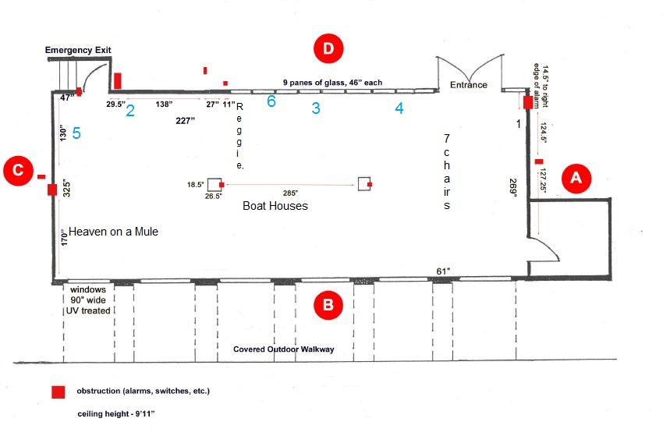

Exhibition Timeline
The exhibition will be opened after 18 months
18 months before opening | - Choice of subject/artist considered by Walsh gallery and Meet with the staff and Coordinator to discuss initial idea, space, and dates.  - Discussion sourcing of materials that will be used in the exhibition.
14 - 18 months before opening | - Researching and planning.  - Curator meets with necessary staffs to select where the objects take from that will be used /discuss the objects.  - Develop the idea/theme/narrative.
12– 14 months before opening | - Curator creates preliminary objects list.  - Curator make sure about the Walsh gallery catalogue for design safety, lights, temperature, entries, lengths to fit with the objects.
10– 12months before opening | - Curator refine the objects list that will present on Walsh gallery.  - Curator consults with conservation head to ship the object to the Wash gallery.
8 – 10months before opening | - The curator has objects list ready for installation.  - The curator starting writing labels.
6– 8months before opening | - planning what is educational programs to fit for audience.  - Working on the exhibition to make sure everything is working plus the conjunction with the theme.
4– 6months before opening | - Writing the artist statement and continued public advertisement
3-4months before opening | - Writing the artist statement of the press release and made for online exhibition public.  - Take labeled postcards to Walsh gallery for mailing.
2-3months before opening | Install the objects in the Walsh gallery.
1-2month before opening | Opening front desk/Reception/Exhibition.
1-Month | De-installation
Key staff
The Member staffs of Walsh Gallery at Seton Hall University believe that the core mission of Walsh gallery is to collect, preserve, study, interpret, and display works of art for the benefit of the public. The staffs on this gallery dedicated professionals trained in the history of art, history, and developing exhibitions. Although the staffs have many duties, experiences, and responsibilities, their primary value to the Walsh Gallery lies in their specific expertise. The Member staffs of Walsh Gallery at Seton Hall University believe that the core mission of Walsh gallery is to collect, preserve, study, interpret, and display works of art for the benefit of the public. The staffs on this gallery dedicated professionals trained in the history of art, history, and developing exhibitions. Although the staffs have many duties, experiences, and responsibilities, their primary value to the Walsh Gallery lies in their specific expertise. The staff members currently that work on this exhibition:
Gallery Curator :
Meaeel Alraithi
352-575-4534
Meaeel.alraithi@shu.edu
Meaeel Alraithi is the Director of the Walsh Gallery at Seton Hall University. He earned himself M.A. in Museum Studies at Seton Hall University 2017. He has taught at College of Arts and Humanities for Cities and archaeological sites in the Kingdom, including: manuscripts, tourism resources in the Kingdom, tourist patterns, tourism development, archeological research methods, international tourism legislation and regulations 2014.
Collections Manager,
Romana Schaeffer is the collections manager who will be tasks with all the issues related to the collections. She is the collections manager in the Walsh gallery having obtained her M..A in museum studies from the Seton University with the study of Native American history with minors in the Museum studies and Anthropology in her undergraduate studies from the New York University. She has 10 years’ experience in collections management with research on effects of colonization on Native American group.

Gallery Assistant.
Jesse Benicaso
(973) 275-2037
jesse.benicaso@shu.edu
Jesse Benicaso is the Walsh Gallery’s Collections Assistant. He has worked previously at Renwick Fine Art Services and Cadogan Tate Art Services as an Art Handler – with extensive experience preparing art for storage, shipping and installation. His formal experience in the industry consists primarily of working for fine art services and galleries throughout the tri state area.
Curator Resume
Meaeel Raee Alraithi CV 1 carriage city plaza
Rahway, NJ 07065
001 352 5755 356
am2010am11@hotmail.com
PROFESSIONAL PROFILE
A motivated and enthusiastic professional dedicated to the field of Tourism and Archelogy, with particular interest in museum studies. Seeking to secure a museum internship and further education, developing core competencies through practical experience and professional development. With the view of going onto establish a successful career, becoming an expert in museums and making museum studies usable in society. Long term objectives include disseminating knowledge and skills to the next generation through actively engaging in academics.
Key Skills:
- Effective communicator, with active listening and persuasive language skills.
- Strong team worker, collaborating well with others.
- Able to take responsibility and work independently.
- Apt relationship building capabilities.
- Strong bi-lingual capabilities in Arabic and English
- Experienced in meeting demanding challenges and working under time pressure.
- Quality organizer with meticulous attention to detail.
- Exceptional leadership and managerial skills.
- Advanced computer skills, proficient in MS office and various other software.
EDUCATION

Seton Hall University, New Jersey, USA Graduate Student: Museum Studies Present
University of Florida, Florida, USA Intensive Program in English Language 10/24/ 2014 – 02/ 11/ 2015
Savannah College of Arts and Design, Georgia, USA Intensive Program in English Language 02/20/ 2015 – 08/05/2016
Jazan University, Jazan, Saudi Arabia Bachelor degree in Tourism and Archelogy January 2013
Additional Training
FIFA Traveling and Tourism Agency Amadeus and Galileo System Training Three Months
The cycle of self-construction and success in life 2012

Professional Experience
- Jazan University, Jazan, Saudi Arabia Teaching Assistant: College of Arts and Humanities June 2013
- Taught for Cities and archaeological sites in the Kingdom, including: manuscripts, tourism resources in the Kingdom, tourist patterns, tourism development, archeological research methods, international tourism legislation and regulations. 2014
-  Jazan University, Jazan, Saudi Arabia Student Supervisor: Almnarh prospecting training of ancient monuments 2014
Conferences / Participation work
- Supervised and participated in the scientific field visit to the site of the warm tourist eye and the site of Dahan with students of Jazan Universty, the Department of Tourism and Antiquities. 2014
- The National Museum of African American History and Culture, Washington DC, USA July 2017 – August 2017
- Seton Hall University, attended lecture by Dr. Maxwell Anderson on “Saving the Past: Next-Generation Challenges in Heritage Protection.” February 2016
- International Conference on Higher Education, Riyadh, Saudi Arabia
- The Fifth Scientific Forum for Archaeological Studies, title "The Effects and Heritage of the Jazan Region through the Ages" February 2014.

Memberships
- Member of the Committee on Quality and Academic Accreditation, Department of Tourism and Archeology, Jazan University 2013

Interests
- Restoration of ancient monuments
- Historic preservation
- Antiquities and evaluation

